SIMATS ENGINEERING
DEPARTMENT OF COMPUTER SCIENCE AND ENGINEERING
DESIGN AND ANALYSIS OF ALGORITHMS
CO1 ASSESSMENT TOOL – 1 REPORT
QUESTION 1
APPLICATION: ONLINE VIDEO STREAMING PLATFORM
Student Name: Adhiti . S
Register Number: 192411069
Faculty Name: Dr Rajagopal K
Course Code: CSA0606
Course Name: Design and Analysis of Algorithms
Date of Submission: 20-07-2026
ABSTRACT
The analysis of algorithm efficiency plays a significant role in designing software systems capable of handling large-scale computational tasks. Many real-world applications, including online video streaming platforms, rely on divide-and-conquer algorithms to process vast amounts of user requests efficiently. These algorithms recursively divide a problem into smaller subproblems, solve them independently, and combine the results to produce the final output. The execution time of such recursive algorithms is commonly represented using recurrence relations, which can be analysed using the Master Theorem.
This report presents the analysis of the recurrence relation T(n) = 2T(n/2) + n, which models the processing of user requests in an online video streaming platform. The Master Theorem is applied to identify the recurrence parameters, determine the appropriate case, and derive the asymptotic time complexity. The report demonstrates that the given recurrence satisfies Case 2 of the Master Theorem, resulting in a time complexity of Θ(n log n). This complexity indicates that the algorithm performs efficiently as the number of users increases, making it well suited for applications that require high scalability and fast response times.
In addition to the theoretical analysis, the report discusses the practical significance of divide-and-conquer algorithms in streaming services, presents the implementation through a C program, and evaluates the algorithm's performance using asymptotic notations such as Big-O, Big-Theta, and Big-Omega. The findings highlight how mathematical analysis of recursive algorithms helps software engineers design systems capable of processing large workloads while maintaining optimal performance and resource utilisation.
Keywords: Divide and Conquer, Master Theorem, Recurrence Relation, Time Complexity, Algorithm Analysis, Online Video Streaming Platform, Asymptotic Analysis, Scalability.

- INTRODUCTION
In today's digital era, online video streaming platforms have become one of the most widely used internet services, allowing millions of users to access multimedia content anytime and anywhere. Popular platforms such as Netflix, YouTube, Disney+, and Amazon Prime Video process an enormous number of user requests every second. These requests include searching for videos, generating personalised recommendations, retrieving metadata, managing content delivery, and streaming high-quality video. As the number of users continues to grow, the efficiency of the underlying algorithms becomes a crucial factor in ensuring fast response times and a seamless viewing experience.
To handle such large-scale computational tasks efficiently, modern software systems often employ the Divide and Conquer algorithmic paradigm. This strategy breaks a complex problem into smaller, manageable subproblems, solves each subproblem recursively, and combines the individual solutions to obtain the final result. Since the execution of recursive algorithms depends on the size of the input, their running time is expressed using recurrence relations. Analysing these recurrence relations helps software engineers predict the performance and scalability of an algorithm before it is implemented in real-world systems.
The Master Theorem is one of the most important mathematical tools used to solve recurrence relations of divide-and-conquer algorithms. Instead of repeatedly expanding the recurrence relation, the theorem provides a direct method to determine the asymptotic time complexity by comparing the recursive work with the non-recursive work performed at each stage of execution. This simplifies the analysis and helps identify whether an algorithm is efficient for large input sizes.
In this report, the recurrence relation
T(n)=2T(n2)+nT(n)=2T\left(\frac{n}{2}\right)+nT(n)=2T(2n​)+n
is analysed using the Master Theorem in the context of an Online Video Streaming Platform. The parameters of the recurrence are identified, the applicable case of the Master Theorem is justified, and the overall time complexity is determined. Furthermore, the report discusses how the obtained complexity influences the scalability of the platform when the number of users increases. A simple C program is also implemented to demonstrate the recurrence analysis, and the results are interpreted using asymptotic notations such as Big-O, Big-Theta, and Big-Omega.
The objective of this study is not only to determine the theoretical time complexity but also to understand its practical significance in designing scalable and high-performance streaming platforms capable of serving millions of users efficiently.
2. AIM
The primary aim of this study is to analyse the recurrence relation T(n) = 2T(n/2) + n using the Master Theorem and determine its asymptotic time complexity in the context of an Online Video Streaming Platform. The study also aims to understand how divide-and-conquer algorithms improve computational efficiency, evaluate their scalability as the number of user requests increases, and interpret the algorithm's performance using standard asymptotic notations such as Big-O (O), Big-Theta (Θ), and Big-Omega (Ω).
3. OBJECTIVES
- To understand the concept of divide-and-conquer algorithms and their applications in modern computing systems.
- To study the recurrence relation associated with an online video streaming platform.
- To identify the Master Theorem parameters (a, b, and f(n)).
- To determine the appropriate case of the Master Theorem for the given recurrence relation.
- To calculate the asymptotic time complexity of the algorithm.
- To analyse the scalability of the algorithm as the number of users increases.
- To implement a simple C program that demonstrates the recurrence analysis.
- To interpret the algorithm's efficiency using asymptotic notations and discuss its practical significance in large-scale streaming systems.

4. PROBLEM STATEMENT
Online video streaming platforms process a massive number of user requests every second. To improve performance, these systems often use divide-and-conquer strategies that recursively divide the workload into smaller subproblems before combining the results. The execution time of such recursive algorithms is represented using recurrence relations.
For this application, the recurrence relation is given as:
T(n)=2T(n2)+nT(n)=2T\left(\frac{n}{2}\right)+nT(n)=2T(2n​)+n
where:
- 2T(n/2) represents two recursive calls, each processing half of the input data.
- n represents the linear amount of work performed outside the recursive calls, such as merging processed results or organising user information.
The objective is to apply the Master Theorem to determine the asymptotic time complexity of the recurrence relation. The analysis should include identifying the theorem's parameters, justifying the applicable case, and interpreting how the resulting complexity affects the scalability and performance of an online video streaming platform as the number of concurrent users increases.

5. BACKGROUND THEORY
5.1 ALGORITHM ANALYSIS
Algorithm analysis is the process of evaluating an algorithm's efficiency in terms of the time and memory required to execute it. Instead of measuring performance on a specific computer, algorithm analysis focuses on how the required computational resources grow as the input size increases. This helps software developers compare different algorithms and choose the most efficient one for a given application. The performance of an algorithm is commonly expressed using asymptotic notations, which describe the growth rate of execution time without depending on hardware specifications or programming language.
5.2 DIVIDE AND CONQUER TECHNIQUE
Divide and Conquer is one of the most powerful algorithm design strategies used in computer science. The basic idea is to divide a complex problem into several smaller subproblems of the same type, solve each subproblem recursively, and then combine the individual solutions to obtain the final answer.
The divide-and-conquer strategy consists of three stages:
Divide
The original problem is divided into two or more smaller subproblems.
Conquer
Each subproblem is solved independently using recursion. If the problem size becomes sufficiently small, it is solved directly without further division.
Combine
The solutions of all subproblems are merged to obtain the final solution to the original problem.
This approach significantly reduces computational complexity and is widely used in efficient algorithms such as Merge Sort, Quick Sort, Binary Search, Closest Pair of Points, and Fast Fourier Transform (FFT).
5.3 RECURRENCE RELATIONS
A recurrence relation is a mathematical equation that expresses the running time of a recursive algorithm in terms of the running time for smaller input sizes. It provides a systematic way to analyse recursive algorithms without executing them.
A general recurrence relation can be represented as:
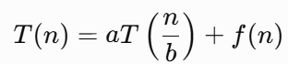
where:
- T(n) represents the total execution time for an input of size n.
- a denotes the number of recursive calls.
- b represents the factor by which the input size is reduced in each recursive call.
- f(n) represents the work performed outside the recursive calls, such as partitioning, merging, or processing data.
Recurrence relations play an important role in analysing divide-and-conquer algorithms because they describe how the running time evolves as the problem size decreases.
5.4 IMPORTANCE OF MASTER’S THEOREM
Expanding recurrence relations repeatedly to determine the running time can become tedious and mathematically complex for large inputs. The Master Theorem provides a direct and systematic method for solving a broad class of recurrence relations without the need for repeated expansion. It compares the amount of work performed recursively with the work performed outside recursion to determine the dominant factor affecting the algorithm's running time.
6. APPLICATION OVERVIEW
6.1 WORKING PRINCIPLE
The processing of user requests in an online streaming platform follows a systematic workflow:
- The platform receives multiple user requests simultaneously.
- The requests are divided into two equal groups.
- Each group is processed independently using recursive techniques.
- The processed results from both groups are merged.
- The final response is delivered to the users.
6.2 WHY IS DIVIDE AND CONQUER SUITABLE?
Large-scale streaming platforms experience unpredictable traffic throughout the day. During live sports events, movie premieres, or popular content releases, millions of users may access the platform at the same time.
Processing every request sequentially would lead to:
- Increased response time
- Higher server load
- Poor user experience
- Reduced system throughput
The Divide and Conquer strategy overcomes these limitations by breaking the workload into smaller, independent tasks. Since each subproblem can be processed simultaneously on different processors or servers, the platform achieves faster execution and improved resource utilisation.

7. SYSTEM WORKFLOW
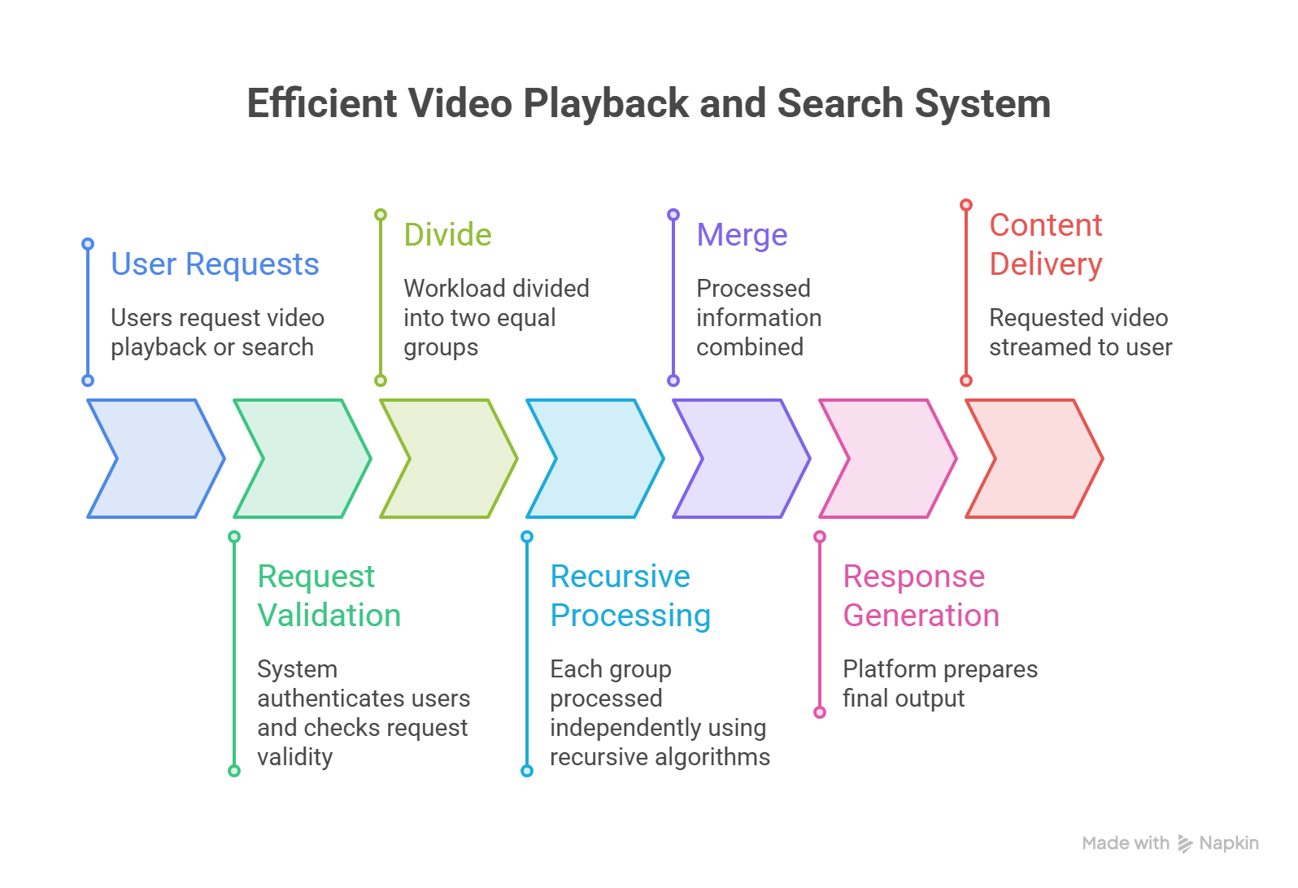

8. MASTER THEOREM IMPLEMENTATION AND ANALYSIS
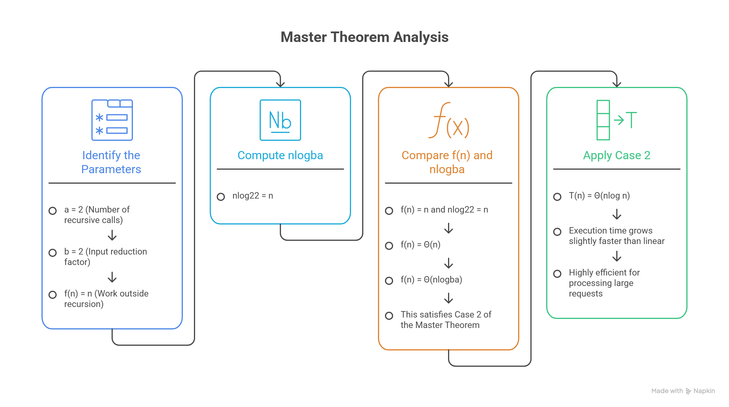

9. IMPLEMENTATION
9.1 OVERVIEW OF IMPLEMENTATION
To demonstrate the practical application of the Master Theorem, a simple C program was developed. The purpose of this program is not to recursively execute the recurrence relation but to illustrate the process of identifying the recurrence parameters, determining the applicable Master Theorem case, and displaying the corresponding asymptotic time complexity. The program accepts the input size from the user, displays the recurrence relation, identifies the values of a, b, and f(n), and finally prints the complexity obtained through the Master Theorem. This implementation serves as a simple demonstration of recurrence analysis and helps understand how theoretical concepts can be represented programmatically.
9.2 DEVELOPMENT ENVIRONMENT
Component | Description
Programming Language | C
Compiler | Online C Compiler
IDE | Visual Studio Code / CodeBlocks
Operating System | Windows 10 / Windows 11
Processor | Intel / AMD Processor
RAM | 8 GB or above

10. SOURCE CODE
#include <stdio.h>

int main() {
int n;

printf("Online Video Streaming Platform\n");
printf("Enter number of users (n): ");
scanf("%d", &n);

printf("\nRecurrence Relation:\n");
printf("T(n) = 2T(n/2) + n\n");

printf("\nMaster Theorem Parameters:\n");
printf("a = 2\n");
printf("b = 2\n");
printf("f(n) = n\n");

printf("\nSince n^(log2 2) = n,\n");
printf("Case 2 of Master Theorem applies.\n");

printf("\nTime Complexity = Theta(n log n)\n");
printf("Big-O = O(n log n)\n");
printf("Scalability: Efficient for large user data.\n");

return 0;
}
11. PROGRAM OUTPUT
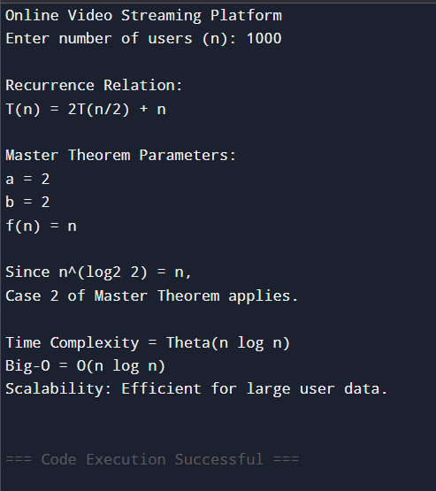

12. COMPLEXITY ANALYSIS
Complexity Measure | Result
Best Case | Θ(n log n)
Average Case | Θ(n log n)
Worst Case | Θ(n log n)
Big-O | O(n log n)
Big-Theta | Θ(n log n)
Big-Omega | Ω(n log n)

13. SCALABILITY ANALYSIS
Scalability refers to the ability of an algorithm or system to maintain acceptable performance as the workload increases.
For an online video streaming platform, scalability is extremely important because the number of users changes continuously throughout the day. During peak hours, millions of users may simultaneously request video content.
The recurrence relation
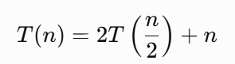
produces a complexity of
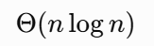
which indicates efficient growth.
As the number of users doubles, the processing time increases only slightly more than double due to the logarithmic factor.
This makes the divide-and-conquer strategy highly suitable for:
- Cloud Computing
- Distributed Computing
- Video Streaming Platforms
- Content Delivery Networks (CDNs)
- Multimedia Data Processing
Furthermore, since the two recursive calls are independent, they can be executed simultaneously on different processors, improving throughput and reducing response time. This characteristic makes divide-and-conquer algorithms particularly valuable in modern distributed systems.
14. ADVANTAGES
- Efficient processing of large datasets.
- Improved scalability for growing user bases.
- Supports parallel and distributed computing.
- Reduces computational complexity compared to brute-force methods.
- Provides predictable performance through mathematical analysis.
- Widely used in industrial applications such as sorting, searching, and multimedia processing.
- Suitable for cloud-based services and large-scale data centres.

15. LIMITATIONS
- It cannot solve arbitrary or irregular recurrence relations.
- Recursive algorithms require additional stack memory.
- Actual execution time also depends on processor speed, memory, compiler optimisation, and hardware configuration.
- The theorem analyses theoretical complexity and does not directly account for real-world factors such as network latency or I/O operations.
16. CONCLUSION
The recurrence relation

was successfully analysed using the Master Theorem. The parameters were identified as a = 2, b = 2, and f(n) = n. Since the function f(n) is asymptotically equal to n^{log₂2}, the recurrence satisfies Case 2 of the Master Theorem. Consequently, the overall time complexity is determined to be 
This result demonstrates that the divide-and-conquer algorithm is highly efficient and scalable for processing large numbers of user requests in an online video streaming platform. The moderate growth rate ensures that the system can handle increasing workloads while maintaining acceptable performance and response times. Therefore, divide-and-conquer remains one of the most effective algorithm design strategies for modern large-scale software systems.

17. REFERENCES
- T. H. Cormen, C. E. Leiserson, R. L. Rivest, and C. Stein, Introduction to Algorithms, 4th ed., MIT Press, 2022.
- E. Horowitz, S. Sahni, and S. Rajasekaran, Fundamentals of Computer Algorithms, 2nd ed., Universities Press, 2008.
- A. V. Aho, J. E. Hopcroft, and J. D. Ullman, The Design and Analysis of Computer Algorithms, Pearson Education, 2007.
- S. Dasgupta, C. Papadimitriou, and U. Vazirani, Algorithms, McGraw-Hill Education, 2008.
- Course Material, Design and Analysis of Algorithms, Department of Computer Science and Engineering, SIMATS Engineering.

